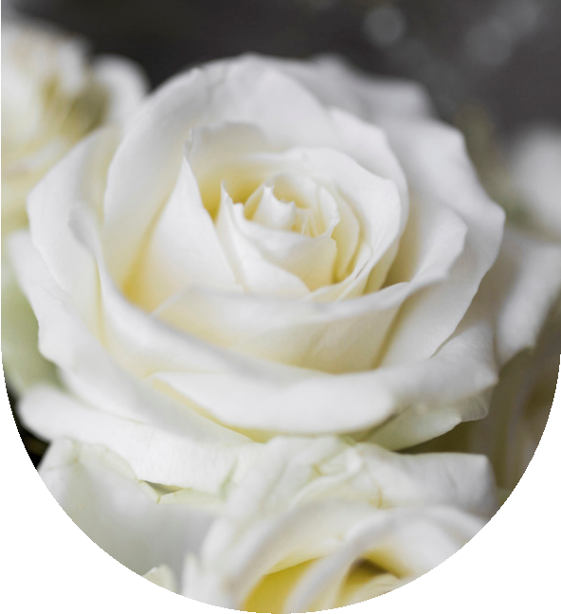
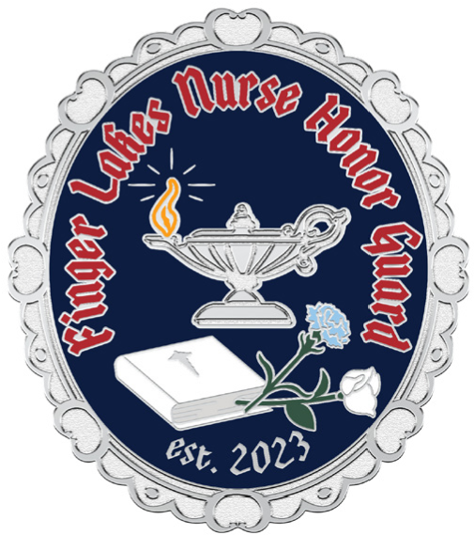
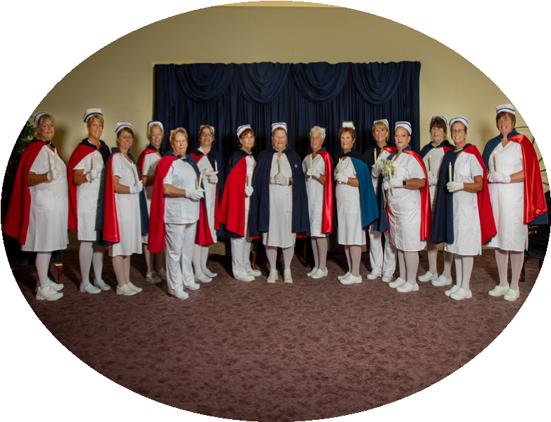
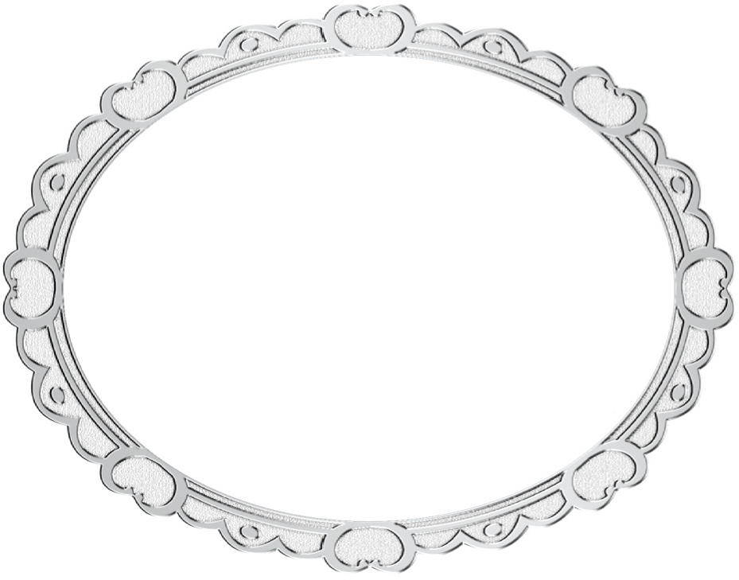

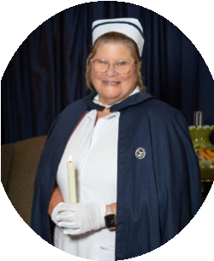

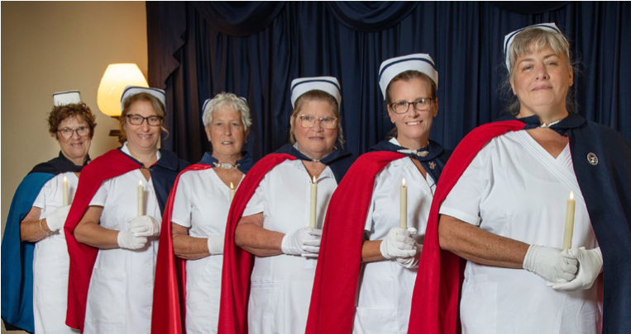
Our Mission
the finger lakes honor guard is
privileged to recognize and honor
those who have dedicated their
lives to serving others in their
chosen profession as a nurse at the
end of their life journey
.
the honor
guard
’
s presence provides meaningful
recognition and honor to a nurse who
has passed
,
and in hopes of easing the
grief of their family members
,
loved
ones and colleagues
.
Nurse
Honor Guard
Finger Lakes
give me strength and wisdom,
when others need my touch;
a soothing word to speak to them,
their hearts yearn for so much.
give me joy and laughter,
to lift a weary soul;
pour in me compassion,
to make the broken whole.
give me gentle, healing hands,
for those left in my care;
a blessing to those who need me,
this is a nurse
’
s prayer.
A Nurse’s
Prayer
The Finger Lakes Honor Guard is
made up of volunteer nurses who serve
based on availability without any
charge to the family.
To request the presence of the
Honor Guard at your loved one’s
service, please call:
Ruth Benjamin
RN, GERO-BC, CRRN,
CDDN, CHPN
founder and president
of finger lakes nurse
honor guard
Phone: 585-766-1187
Email: RBenjamin_RN@outlook.com
Arrangements
FLNHG Board of Directors

